#### Integrated Disability Management ProgramCAPP | A Unified Voice for Canada's Upstream Oil and Gas Industry

Energy for the World.

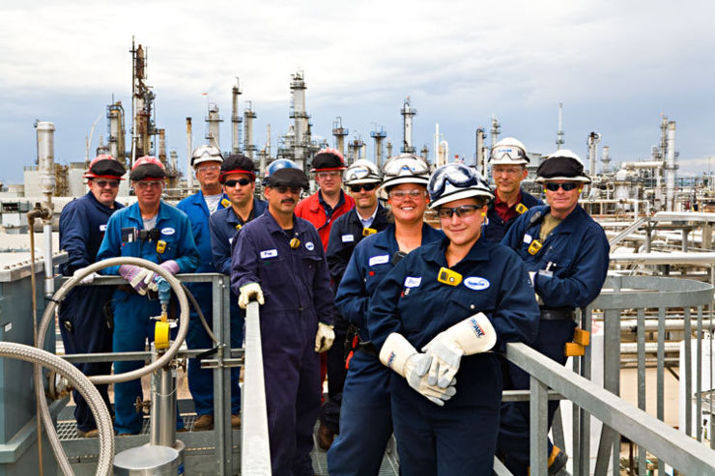

Massive Dynamic Oil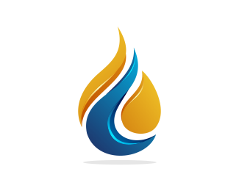

Massive Dynamic Oil



**Disability Management Office**

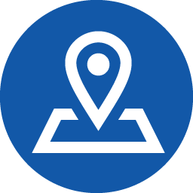 2 Nowhere Avenue, Suite 7 Grande Prairie, AB A72W9U

Monday-Friday 08:30-5:00

Phone: 555.555.0125

After hours: 555.555.0227

massaivedynamicdmc@glotex,ca

**CMA-Union**

 7 Goodyear Street, Suite 3, Grande Prairie, AB, A4F E64,

555.754.9864

cmaunioninfo@glotex.ca

### More information

If you need more information check out the Massive Dynamic Oil website at:

**http://www.massivedynamicoil.com**

There is a web full page dedicated to Integrative Disability Management Program

or check us out on:





### Mission

#### The Integrated Disability Management Program

An Integrated Disability Program is a proactive process in handling and supporting physical and mental health issues that employees may encounter while they are at work. It also integrates firm prevention and early intervention initiatives. This is possible through collaborated effort and teamwork .Massive Dynamic realizes that different models and approaches may be required for different employer needs, work environments and cultures. If an employer requires a time off work, the Disability Management Program will focus on minimizing the impact of injuries and illnesses to allow an early and safe return to work. The program is insured for both short term (up to six months) and long term disability (up to two years depending on state/province)

The Mission of Integrated Management Program is to provide support for anyone who works for Massive Dynamic Oil, by minimizing the overall impact of workplace illness or injury in the most timely, appropriate, and safe manner possible so that everyone benefits.

Return to work is the primary goal.

Return to work is the primary goal.

#### How the Program works? Precede's Disability Management Program: What We Do and What You ...

#### The ill/injured employee alerts the supervisor/line manager of the situation. As soon as the supervisor/line manager notifies the Disability Management Coordinator the claim submission process is started.

Upon first interaction with the employee, the situation is assessed from a medical/ psychosocial point of view in order to determine the needs and requirements to return to work as quickly as safely possible.

Informed consent is given in written format to allow the Disability Coordinator to have access to information from medical/health services which is only used for evaluation purposes of the employee's fitness-to-work status.

Confidentiality of medical information is maintained throughout the process. The information disclosed are ill/injury source, fitness to work status, work limitations and capabilities and a reasonable return-to- work date. Focus is given to address any barriers the employee might have to encourage return-to-work safety and timely.

#### The Integrated Disability Management Team

#### Reaping the Rewards of Benefits Integration - Risk & Insurance ...

Collaboration among stakeholders, is essential to the successful Integrated Disability Management Program

* Employee/Employee
* Union-CMA for unionized workers
* Human Resources
* Disability Case management -Service provider
* Internal Disability Management Team which includes Workers Compensation Board claims administrator

#### Benefits of the Integrated Disability Management Program

Employer: Applies to all workforces (Regular, part-time and seasonal workers) in all locations:

* Timely recovery and decrease of relapse
* Maintain self respect and identity
* Occupational bond is maintained
* Both work and family life is less impacted
* Continued support for return to work in a safe and timely manner
* Lessens the shock of financial hardships due to work place injury
* Dental coverage and extended healthcare
* Access to the Employment Assistance Program
* Worker Compensation support
* Short term/long term disability insurance

Employer

* Help control health-related costs-better return on investment
* Legislative guidelines are met
* Retain employee-less turnover
* Workplace is healthier overall
* Awareness and disability prevention



Disability Management

We are in this together.