# Additional Experience

|  |  |
| --- | --- |
| **Emergency Medical Responder/Standard First Aid Instructor** (Month 1992 - Present) | Canadian Red Cross, NL |

Deliver training courses and conduct skill and knowledge-based evaluations in accordance with Canadian Red Cross outcomes and objectives. Complete accurate and prompt submission of all relevant course documentation.

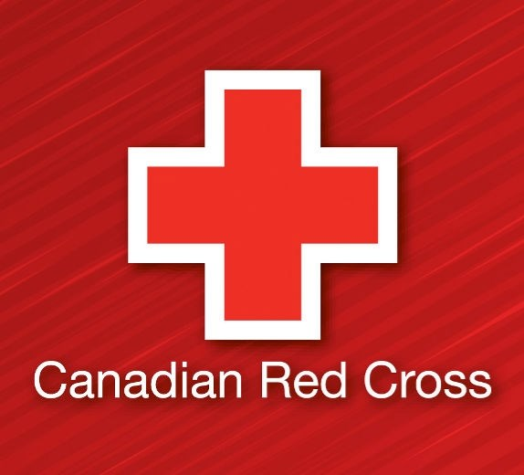

|  |  |
| --- | --- |
| **Inshore Search Rescue** (Month 2005 - Month 2010) | Canadian Coast Guard, NL |

Collaborated with a three-person team using Fast Rescue Craft to respond to Search and Rescue and provided medical assessment and treatment. Conducted patrol of the designated search areas. Led regular boat inspections for the public.

* Conducted public education sessions on such topics as boating safety, personal flotation devices, hypothermia, required safety equipment aboard a vessel, rules of navigation, and boating restrictions and regulations.
* Received Lifesaving award for rescuing 22 people from the sea who were forced to abandon their ship after an engine room explosion; commended for rapid response, team work, and medical knowledge that saved lives.

